MODULE-3

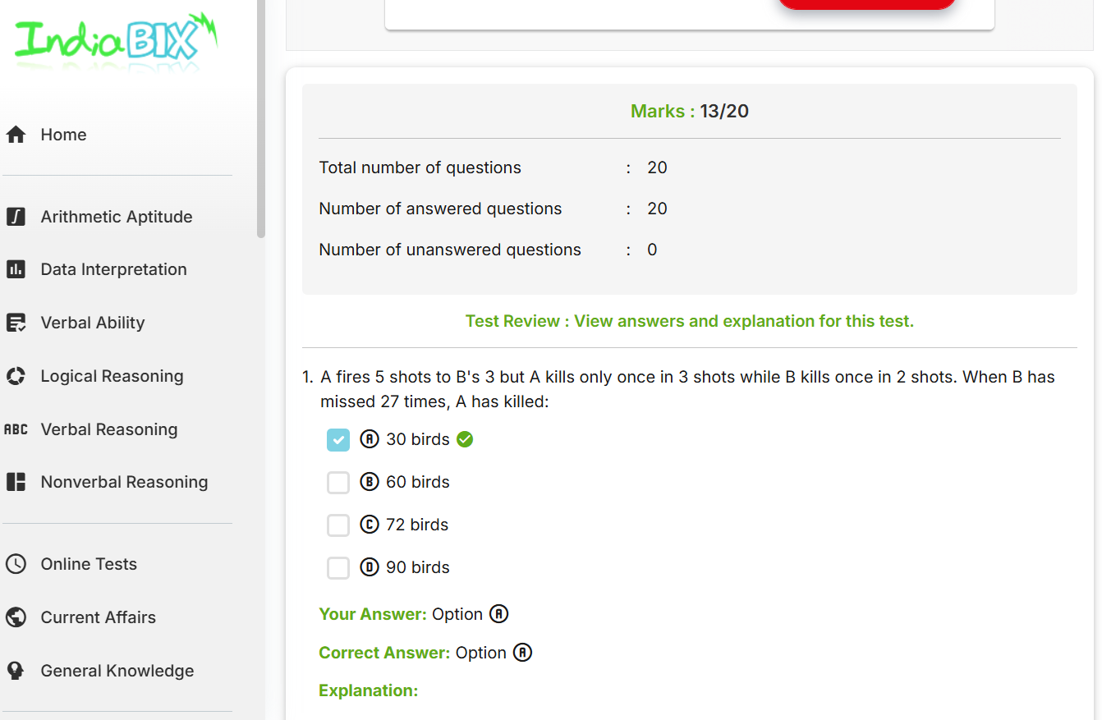Aptitude Test

You tube link

<https://youtube.com/shorts/Awo72HhO-vg?si=yO7WN-u8zgmRbxNi>